Homework 1
Blood Pressure Model
For this exercise, you will need four Matlab files:
1- sa.m : This is your main Matlab file.
2- in_sa.m : This file initiates the values for the previous file
3- psa_new.m : This file is a function that updates the moment to moment values for the systemic blood pressure using Euler’s method.
4- QA_{o}_now.m : This file is a function that updates the moment to moment values for the flow out of the ventricle through the aortic valve into the aorta.
These four files are given on Canvas to download. Download the files in the same directory and study them. They are well annotated. The file, sa.m is the main script and in_sa.m initializes all the constants and initial values of variable. QA₀_now.m looks at the time in each cardiac cycle and decides if the cycle is in systole or diastole. If in systole, it calculates the stroke volume for each $∆t$ between start of systole and end of systole. In diastole, when the aortic valve is closed, the stroke volume is zero. The file, psa_new.m, looks at the blood pressure at each moment in the cycle. It takes the blood pressure at the immediately previous $∆t$ and adds to it the increment of pressure that corresponds to the present time.
Exercises:
- Copy and paste these four files into a new directory in Matlab (give the directory a name that makes it easy to find – I used the very ingenious name: “Blood Pressure”.
Run the code.
  - Show the resulting plots.
  - Adjust the systemic arterial compliance by trial and error to achieve a blood pressure of about 120/80 mmHg.
    - Did you have to increase or decrease the compliance?
    - The adjusted arterial compliance should be considered as the normal value in all subsequent exercises. It might need to be changed again to meet the “experimental” criteria.
    - In all subsequent exercises, be careful to change only the parameter(s) of interest. All other parameters should be reset to the normal values.
  - Note that the pressure starts off at one level and comes into equilibrium after a few beats. Adjust the initial pressure with each exercise so that the pressure curve is in equilibrium ± immediately.
  - Write code to calculate and print the cardiac output (Hint: this can be one simple line of code with a print command or several – both techniques work). Add this code to the main program so that the cardiac output prints out for each of the changes you make subsequently.
- There are two clinical conditions where the systolic pressure is increased, and the diastolic pressure is decreased (widened pulse pressure): arteriosclerosis and aortic insufficiency. We will model aortic insufficiency (also known as aortic incompetence or aortic regurgitation) in homework project 2 when we have a model of the left heart. Arteriosclerosis is a different pathological entity from atherosclerosis. Be careful in your research. When you Google arteriosclerosis, you will find that most articles confound the two pathologies. They are different.
  - Explain, in detail, what each pathology, arteriosclerosis and atherosclerosis, entails and how they differ. This requires a short essay based on histological description.
    - Use annotated images different from those used in class (drawing your own works).
    - Note that both pathologies contribute to the development of hypertension.
    - While arteriosclerosis may reduce arterial diameter somewhat (maybe $≈$5-10%) its major effect is to stiffen the arterial wall significantly. Atherosclerosis introduces significant arterial strictures (stenoses) as well as stiffening the artery
    - What one parameter would you change in the model to best make the model reflect significant wall stiffening from arteriosclerosis?
    - Construct a for/loop in the main Matlab script to change this parameter to make the blood pressures approximately ±140/±65 mmHg and ±180/±50 mmHg. These values are not unusual in older patients with significant arteriosclerosis and account for many cases of idiopathic hypertension in those over 60 years of age.
    - Explain how you changed the MATLAB file (you do not need to show the entire file!), for instance, “I created a for/loop that changes the ___ from its initial value to ___ by increments of ___ …“).
    - Show your plots (labeled as is usually expected) with the parameter values used noted in the plot title
    - Explain why the presence of arteriosclerosis results in increased systolic pressure and decreased diastolic pressure. This will require understanding why a diastolic pressure exists at all. This requires a thoughtful but short essay.

- Now consider arteriolosclerosis.
  - How is arteriolosclerosis different from arteriosclerosis? That is, which vessels are affected and how are they affected? There are multiple causes of arteriolosclerosis but diabetes mellitus is certainly the most common (about 12% of the American population is diabetic or around 38 million people!). Arteriolosclerosis is also a cause of hypertension.
  - What one parameter would you alter to best demonstrate the hypertension caused by arteriolosclerosis in our model?
  - In the script provided, change that parameter to cause a hypertension of about ± 150/105 mmHg. Show your plot and label it to explain what parameter you changed to what value to generate the plot.
  - How is the hypertension generated by arteriolosclerosis different from that of arteriosclerosis?
  - What do the previous, in silica, experiments tell you about the inherent properties of the arteries vs. those of the arterioles?
- Amongst the causes of arterial hypertension, consider obesity. Severe obesity (also called morbid obesity, BMI > 35) is an epidemic in this country ($≈$10% of the population and increasing), especially in the south and Midwest. It is a major cause of hypertension even in younger obese individuals of 12-20 years of age. Severely obese individuals need to perfuse the increased body mass. Adipose tissue is living tissue and needs blood perfusion like any other living tissue. Therefore, cardiac output is increased in these individuals.
  - To simulate the circulation in a morbidly obese person:
    - cardiac output is increased. This occurs naturally in the obese to provide oxygen and nutrition to all that extra tissue. To increase cardiac output, we need to increase heart rate and stroke volume. To increase heart rate, you will need to decrease the period, T and the times in systole, T_{max} & T_{S}, by the same proportion (divide each by 1.25) to increase the heart rate to 100/min.
    - In a morbidly obese teenager without diabetes, arterial compliance and arteriolar resistance will be normal. Leave those parameters at the normal values.
    - Cardiac Output is stroke volume x heart rate (now 100/min). Increase the maximal aortic flow (Q_{max} by 40% over the initial value). Stroke volume is
½ T_{S} x Q_{max}. Since T_{s} has been decreased, Q_{max} must be increased.
    - How does this person’s hypertension differ from the hypertension caused by arteriosclerosis?
      - In terms of pulse pressure and diastolic pressure
    - What is the cardiac output in this obese individual
    - What is the cost to the morbidly obese
    - What does the hypertension do to the work the heart performs to maintain adequate cardiac output
    - Research how the heart compensates for chronic increased workload. Write short essay that explains this cardiac remodeling.
- Next, consider normal exercise. During exercise, systemic resistance falls because of autoregulation in the working muscles (vasodilation of intramuscular arteries and arterioles). As an example, consider a reduction in systemic resistance by a factor of 2. The response of the body is to ± double the cardiac output (so that the systemic arterial pressure will not fall), and this is achieved primarily by increasing heart rate and stroke volume. In the trained athlete, stroke volume can increase markedly. In the rest of us, less so!
  - Halve the arterial resistance

  - We can increase the heart rate in our model by dividing by the same amount all three of the times: T (the duration of the cardiac cycle), TS (the duration of systole), and TMAX (time from start of systole to maximal aortic flow). To achieve a heart rate of ± 120 beats/min divide all three time parameters by 2.
The above prescription is, of course, simplified. When heart rate changes in exercise, the corresponding changes in the duration of systole are less pronounced than those in the duration of the whole cardiac cycle. In other words, systole which occupies 40% of the cardiac cycle at rest, may occupy 50% of the cardiac cycle during exercise. We ignore this slight modification in this model.

  - We can increase stroke volume by increasing QMAX, the maximum aortic flow in liters/min by doubling QMAX.
  - What is the stroke volume and cardiac output at these new settings?
  - What is the blood pressure
  - This truly reflects changes induced during exercise
  - Submit the plots that demonstrate this exercise. What is the new stroke volume and cardiac output and how does it compare to resting values
- Finally, it is of interest to see what happens to the arterial pulse when the normal periodic pattern of heartbeats is temporarily interrupted, as it is in in 2nd degree heart, where some atrial contractions are not transmitted to the ventricles and the beats are dropped block or intermittent 3rd degree block where there is no correlation between atrial activity and ventricular activity, i.e. the atria beat regularly but the ventricles are detached from those signals and beat autonomously at a much lower rate.
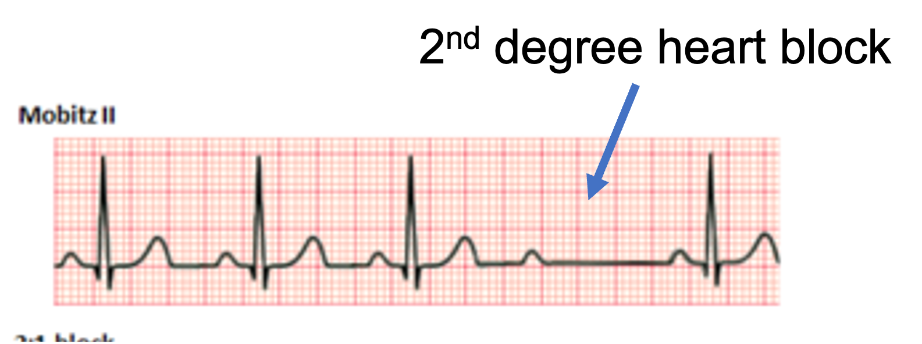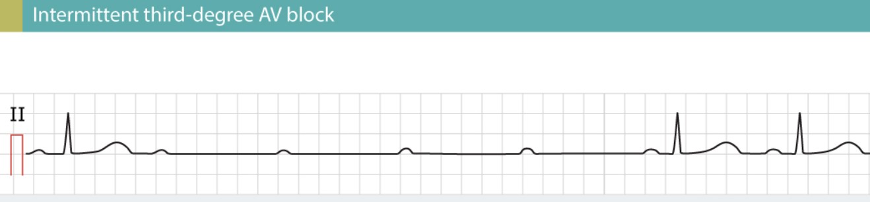
  - The script sa.m runs for 12 sec. (0.2 min). Model the situation of a second-degree block that causes the heart to miss several ventricular beats. Make the cardiac output cease (ventricle does not beat) at 1.8 sec. and resume at 7.8 sec.
  - What happens to the arterial pressure during the arrest period?
  - How long until the blood pressure is adequate to perfuse the brain?
  - To simulate this, we must modify the function QAo_now(t) so that its output is zero between two specified times t_arrest = 0.03 min and t_restart = 0.13 min, and normal otherwise. I’ll leave the programming details to you. Submit your program changes and your plots.
  - Note that the recovery of BP to normal blood pressure is longer than the duration of the block. This explains syncope frequently associated with any significant heart block.

Submit your answers in .doc or .docx format. Be sure your graphics have labeled axis and titles and whatever other information is appropriate.

